**DBMS PROJECT**

**PROJECT REPORT**

**PROJECT IDEA: MULTIPLAYER MATCHMAKING SERVER**

**GROUP MEMBERS:**

**WALEED SIDDIQUI 241906**

**MUHAMMAD HASSAN 241933**

**SCHEMA DESIGN**

**ENTITIES**

**Total Entities: 14**

1. FriendList
2. GameMode
3. GameRequest
4. GameResult
5. Invite
6. Lobby
7. Match
8. Party
9. PartyMembers

10)Platform

11)Player

12)PlayerStats

13)Schedule

14)Server

Server Used: Microsoft SQL Server 2022

**ATTRIBUTES**

**FriendList:**

PlayerID (PK,FK NOT NULL, INT)

FriendID (PK,FK,NOT NULL, INT)

FriendSince(date, null)

**GameMode:**

GameModeID (PK, INT, NOT NULL)

ModeName (VARCHAR(50), NOT NULL)

MaxPlayers(int, null)

**GameRequest:**

RequestID (PK, INT, NOT NULL)

PlayerID (FK, INT, NULL)

PartyID (FK, INT , NULL)

GameModeID (FK, INT NOT NULL)

RequestTime (DATETIME, NULL)

**GameResult:**

ResultID (PK, INT, NOT NULL)

MatchID (FK, INT , NULL)

PlayerID (FK, INT, NULL)

Score (VARCHAR(50), NULL)

Result (VARCHAR(30), NOT NULL)

**Invite:**

InviteID (PK, INT , NOT NULL)

SenderID (FK, INT, NULL)

RecieverID (FK, INT NULL)

PartyID (FK, INT, NULL)

SentAt (datetime, null)

**Lobby:**

LobbyID (PK, INT , NOT NULL)

LobbyName (Varchar(100), null)

MaxPlayers(int, null)

GameModeID (FK, int, null)

ServerID (FK, INT, NULL)

**Match:**

MatchID (PK, INT, NOT NULL)

GameModeID (FK, INT, NULL)

ServerID (FK, INT, NULL)

StartTime (datetime, null)

LobbyID (FK, INT, NULL)

**Party:**

PartyID (PK, INT , NOT NULL)

LeaderID (FK, int, null)

Status ( VARCHAR(30), NULL)

PartyName (VARCHAR(100), NULL)

**PartyMembers:**

PartyID (PK, FK, INT, NOT NULL)

PlayerID (PK, FK, INT, NOT NULL)

**Platform:**

PlatformID (PK, INT, NOT NULL)

PlatformName (VARCHAR(50) NOT NULL)

Manufacturer (VARCHAR(50), NULL)

ReleaseYear (int,null)

**Player:**

PlayerID (PK, INT, NOT NULL)

Username (VARCHAR(50) NOT NULL)

Email (varchar(100), not null)

PlatformID (FK, INT, NULL)

**PlayerStats:**

StatsID (PK, INT, NOT NULL)

PlayerID (FK, INT , NULL)

TotalGamesPlayed (int,null)

TotalWins (int,null)

TotalLosses (int, null)

Rank (VARCHAR(50), null)

**Schedule:**

ScheduleID (PK, INT, NOT NULL)

MatchID (FK, INT , NULL)

ScheduledTime (Datetime, null)

**Server:**

ServerID (PK,INT , NOT NULL)

Location VARCHAR(100), NULL)

Capacity (int, null)

Status (VARCHAR(50), NULL)

**MAIN FEATURES:**

* Allows adding a player as a friend in the FriendList.
* Allows Creating and Joining Party
* A party can send GameRequest for joining a game.
* Shows Game Results after the completion of games.
* Allows Inviting players to the party.
* Connects a lobby with a server.
* Show stats of a particular player.
* Allows scheduling a match
* Displays a schedule of upcoming matches.

**CREATE TABLE QUERIES**

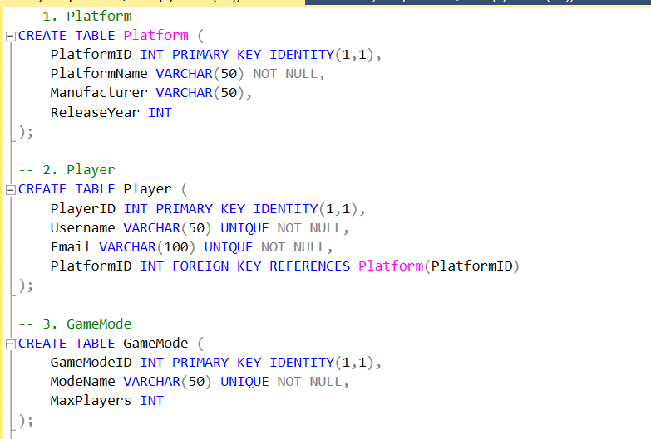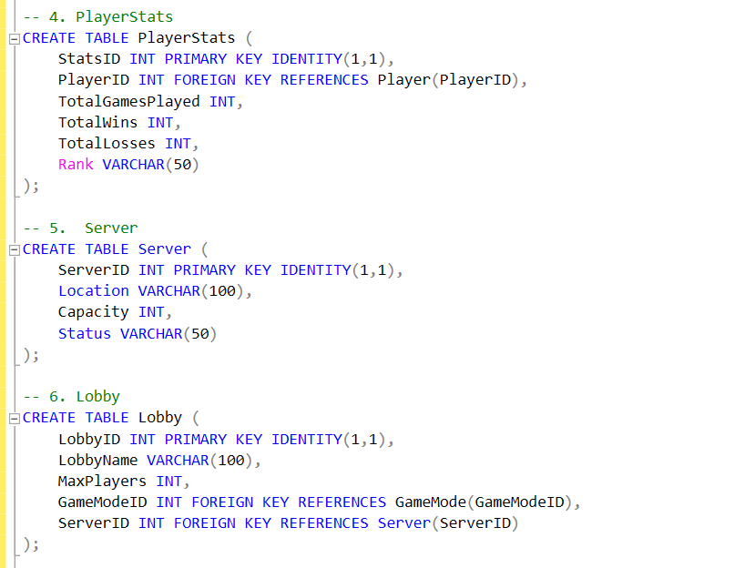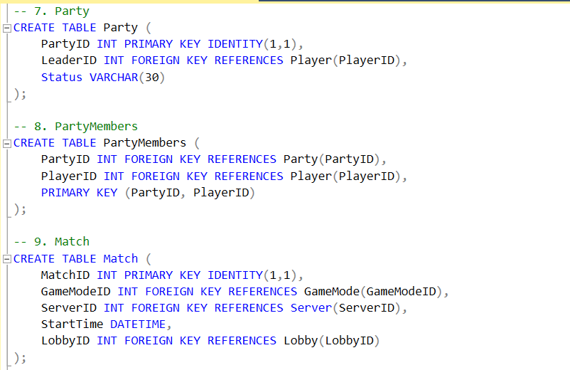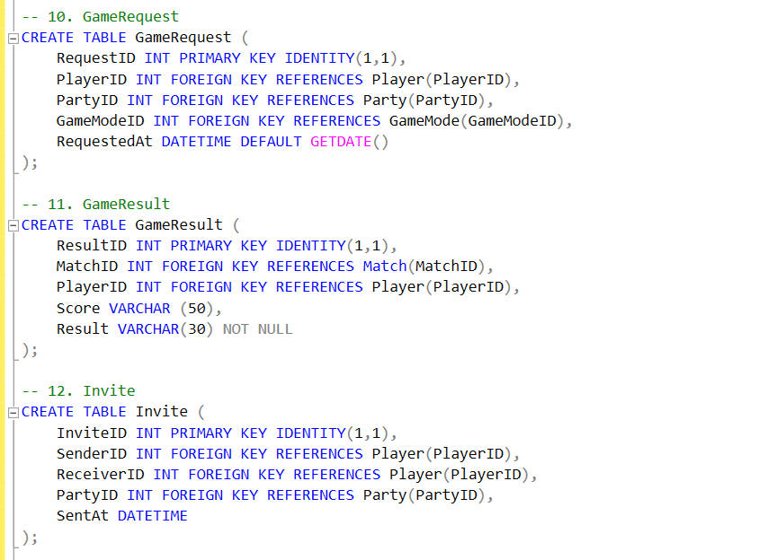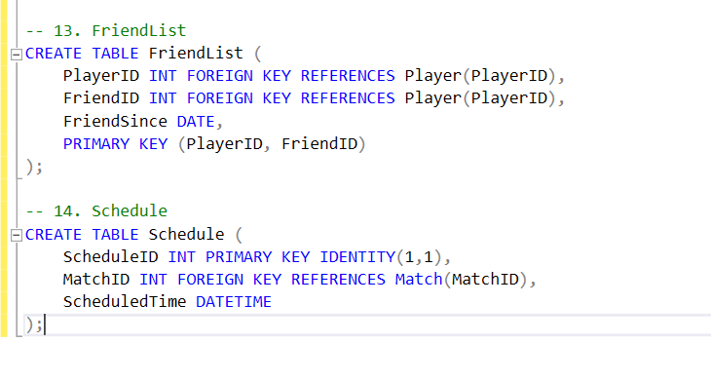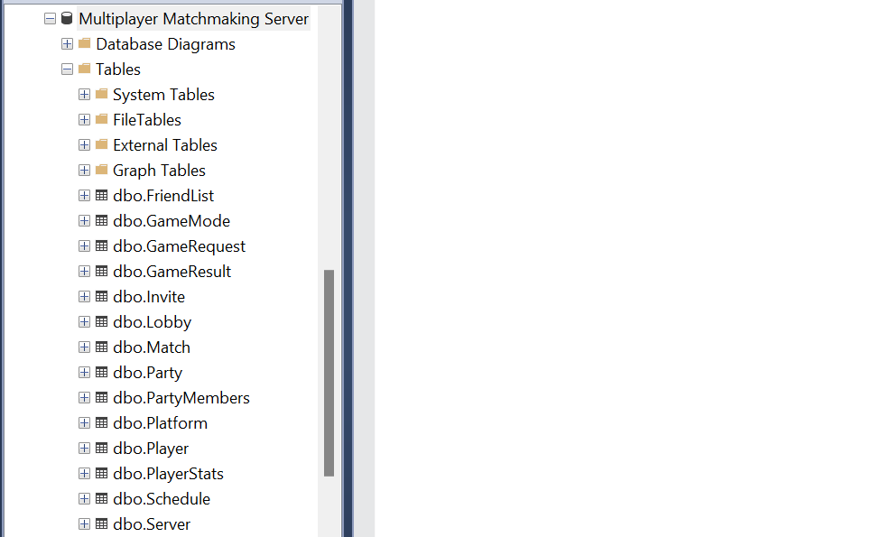

**INSERT DATA QUERIES**

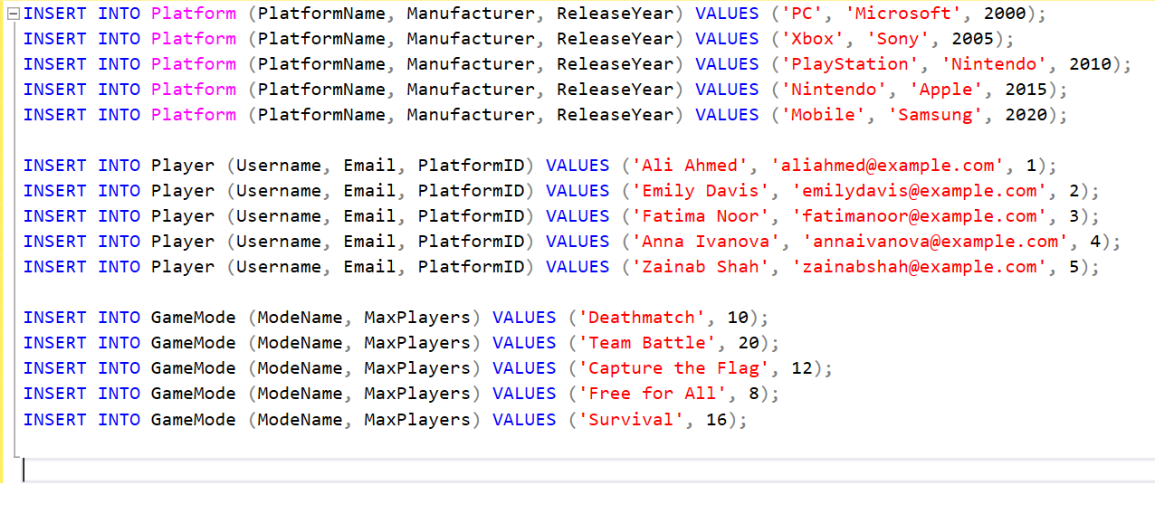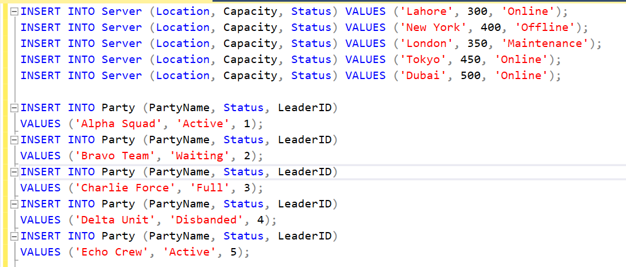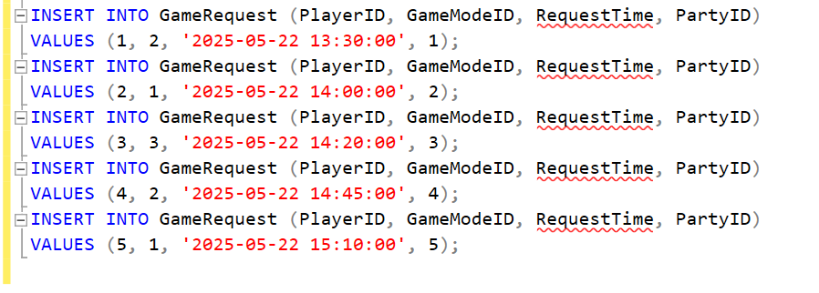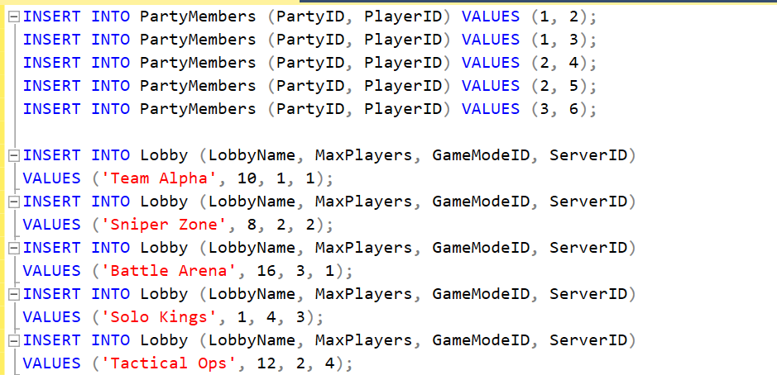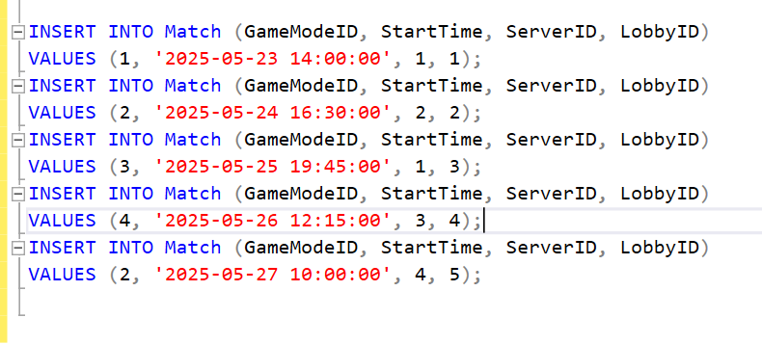 **RETRIEVAL QUERIES**

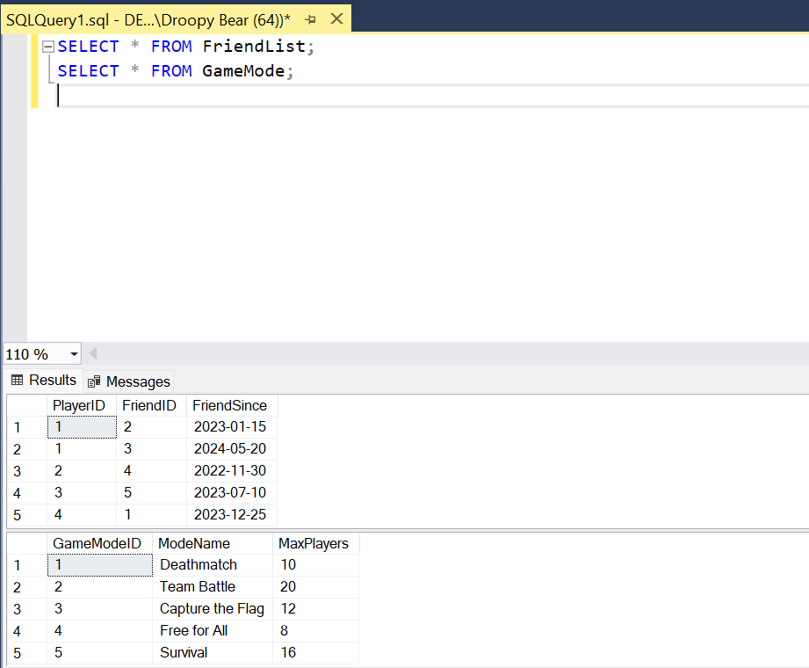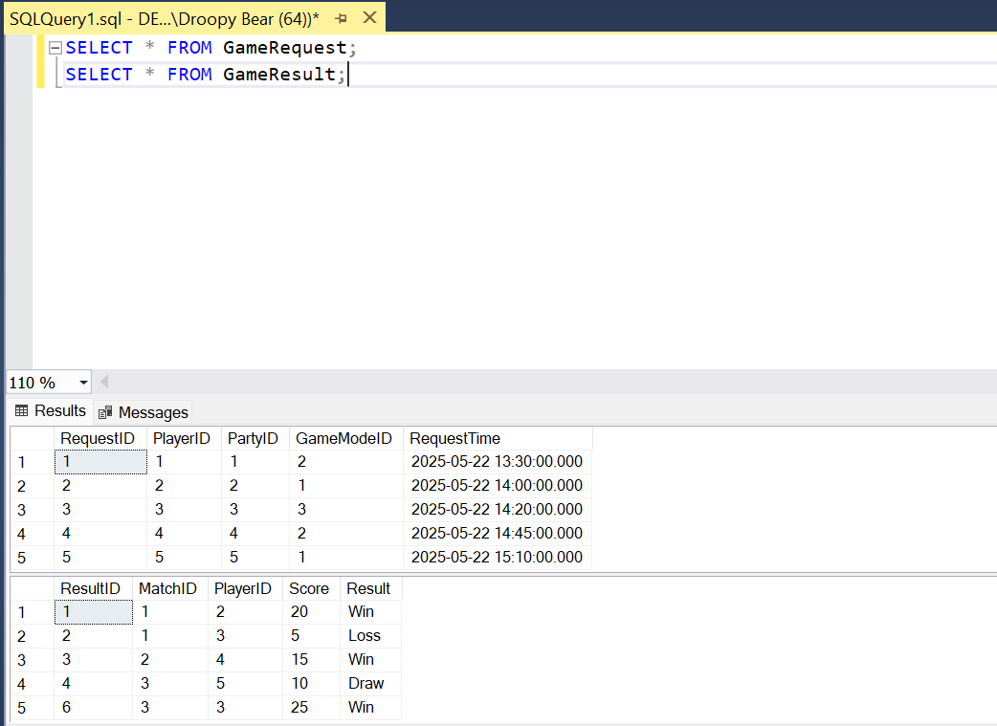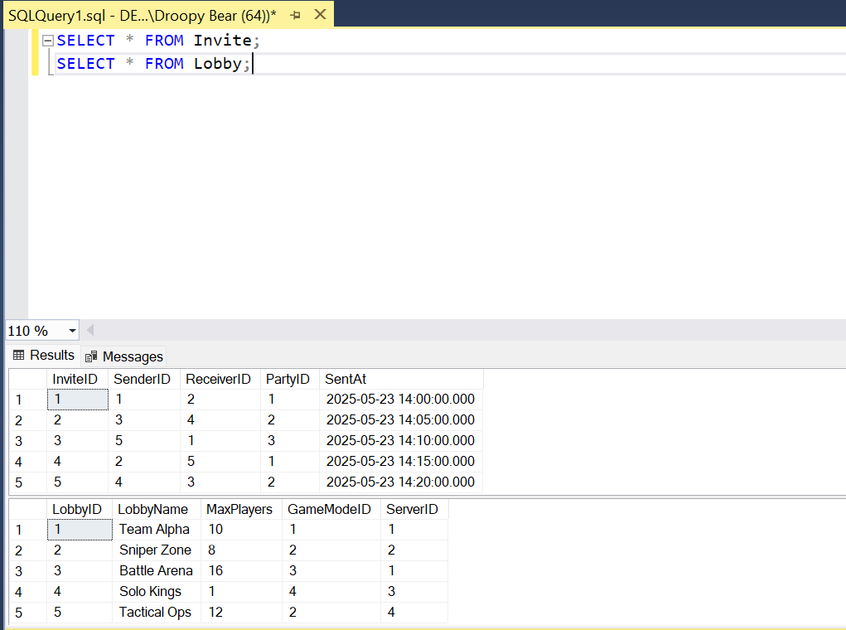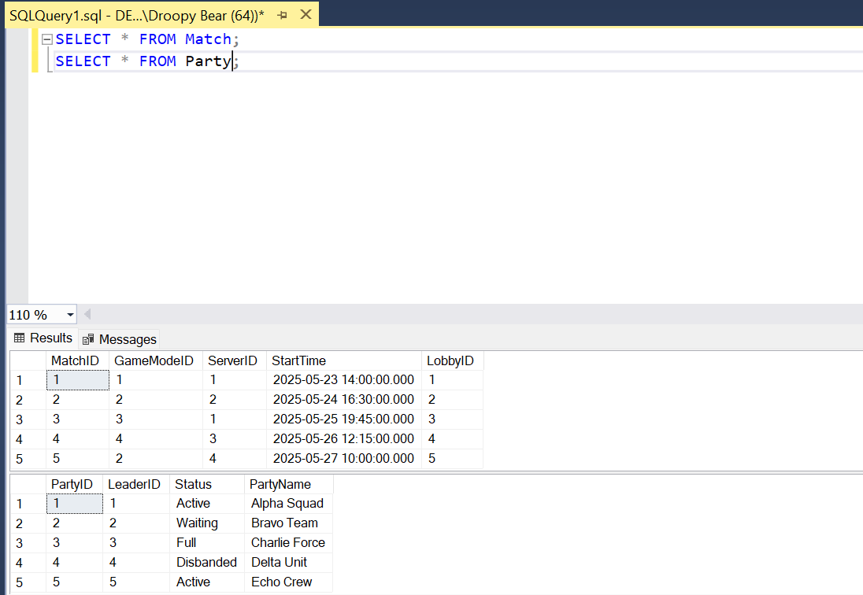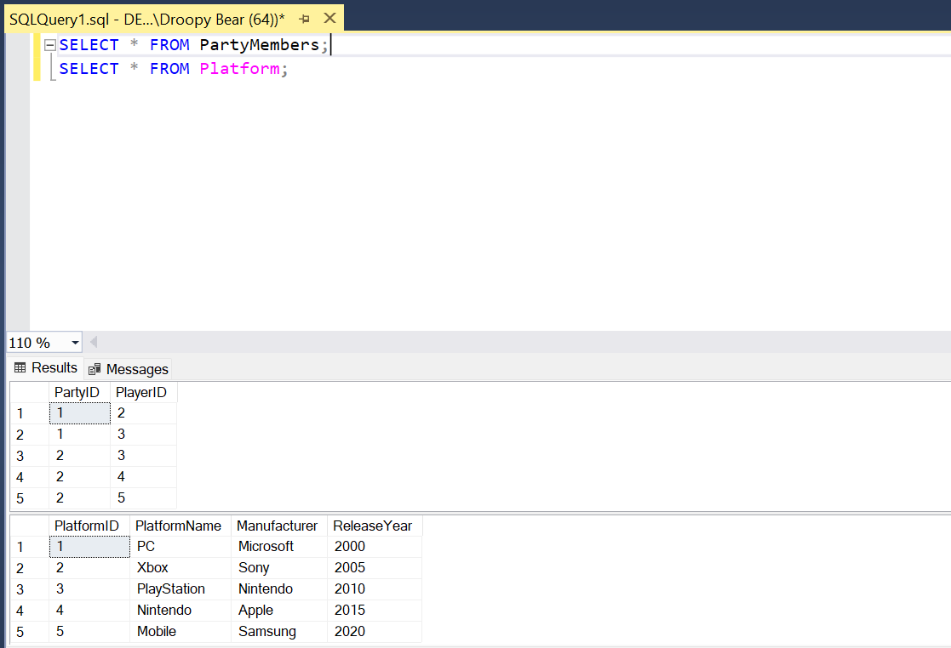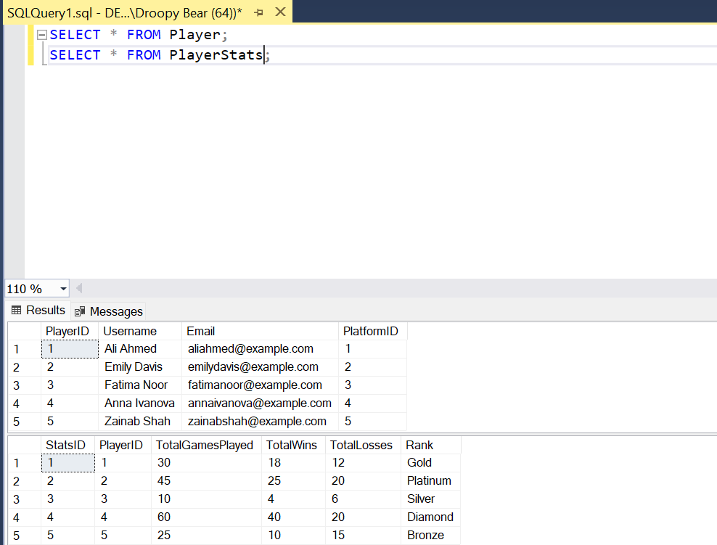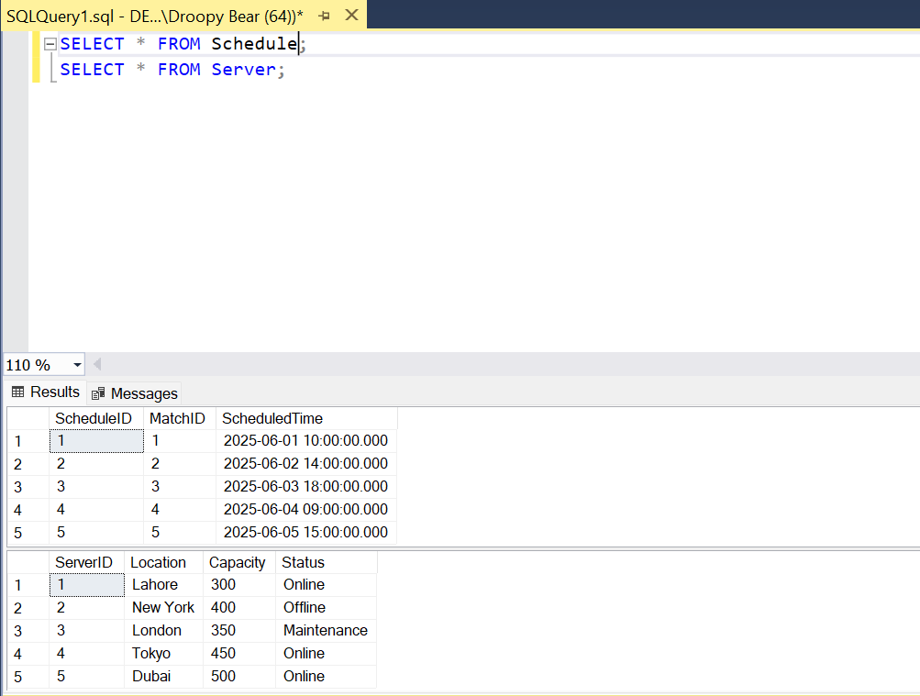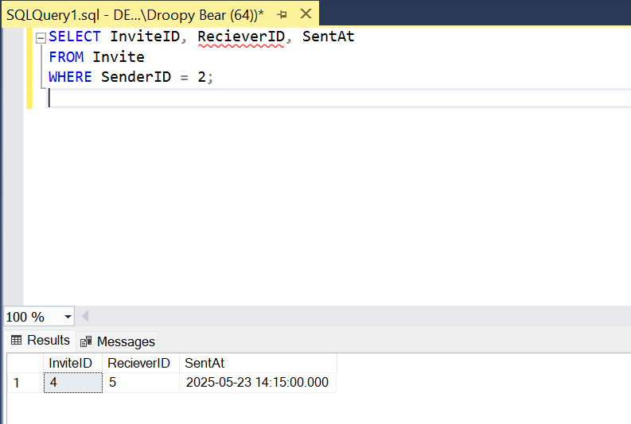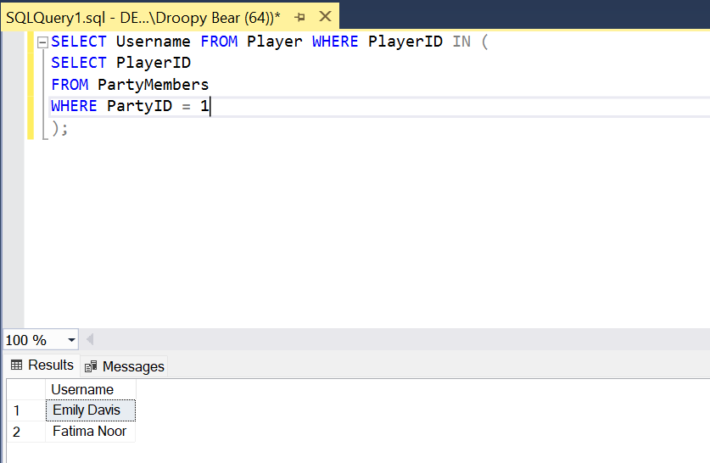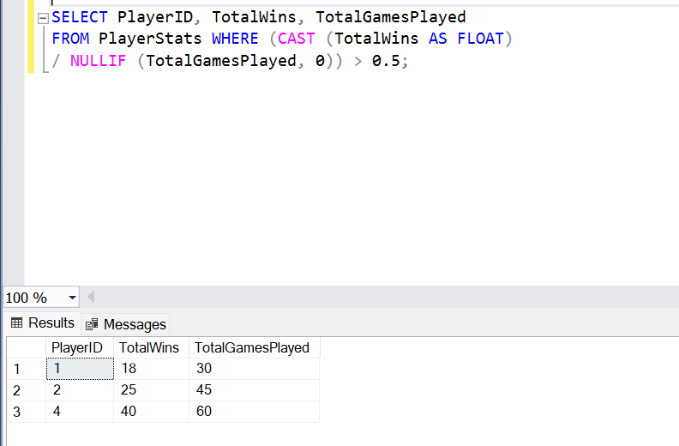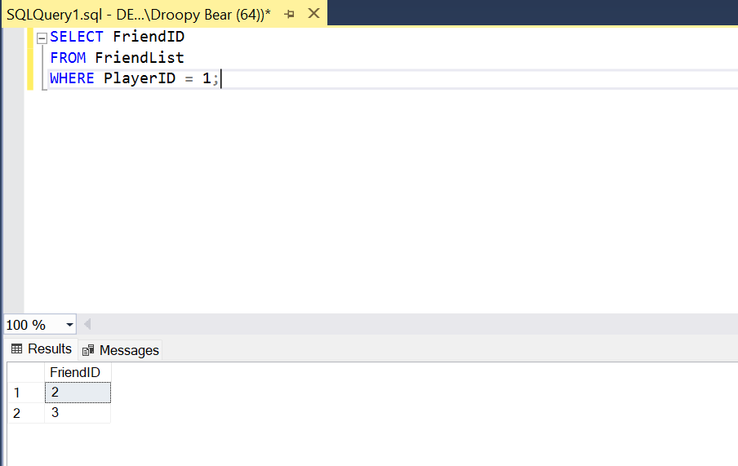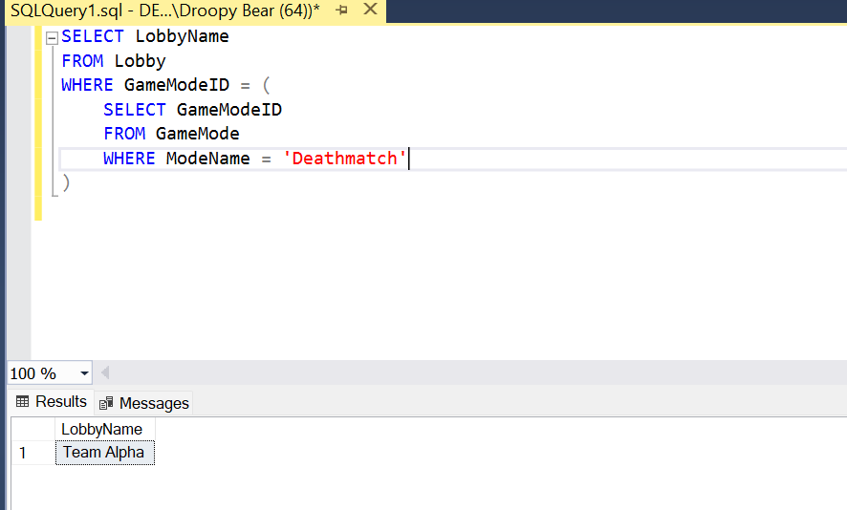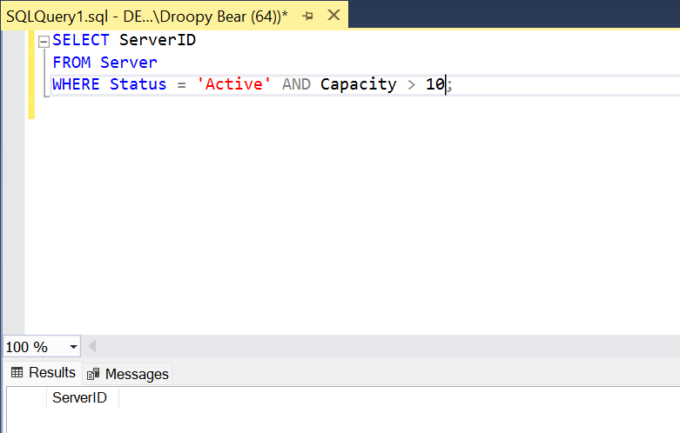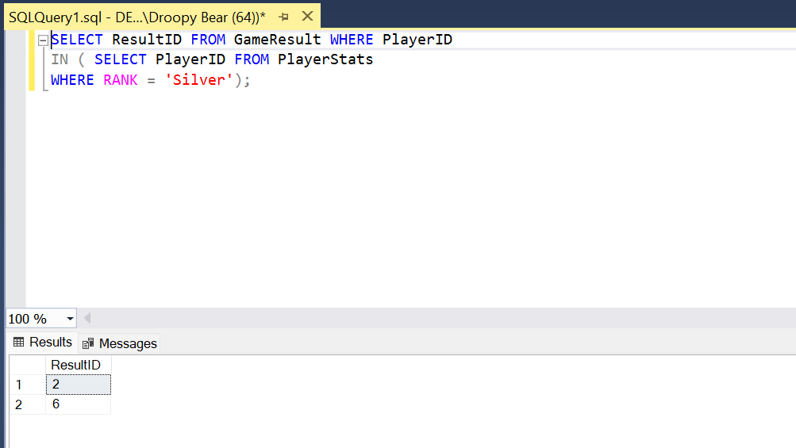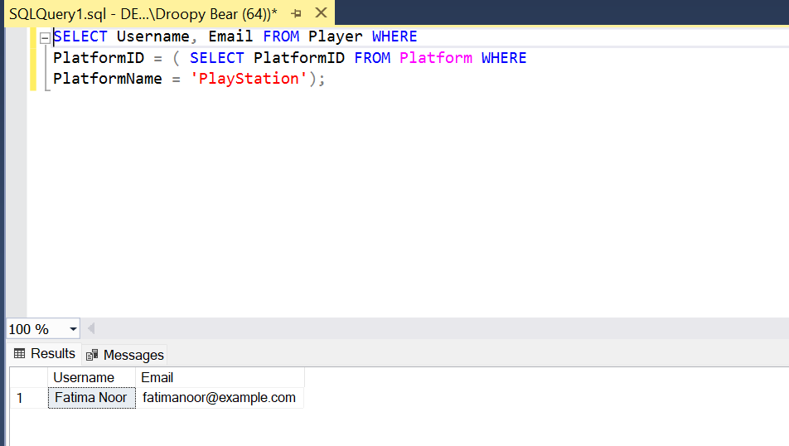

**UPDATE QUERIES**

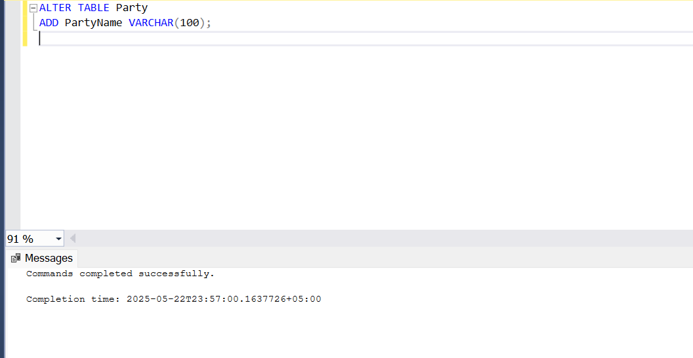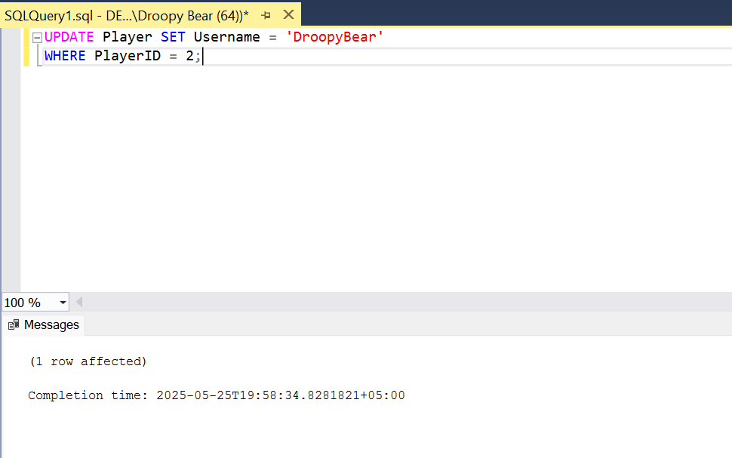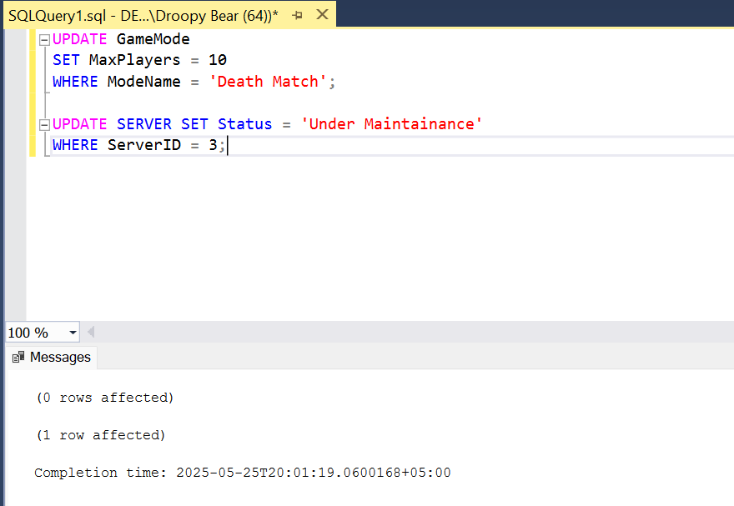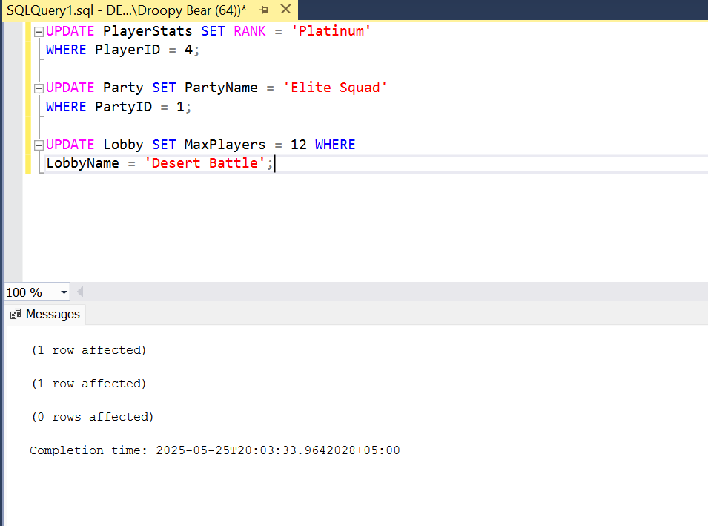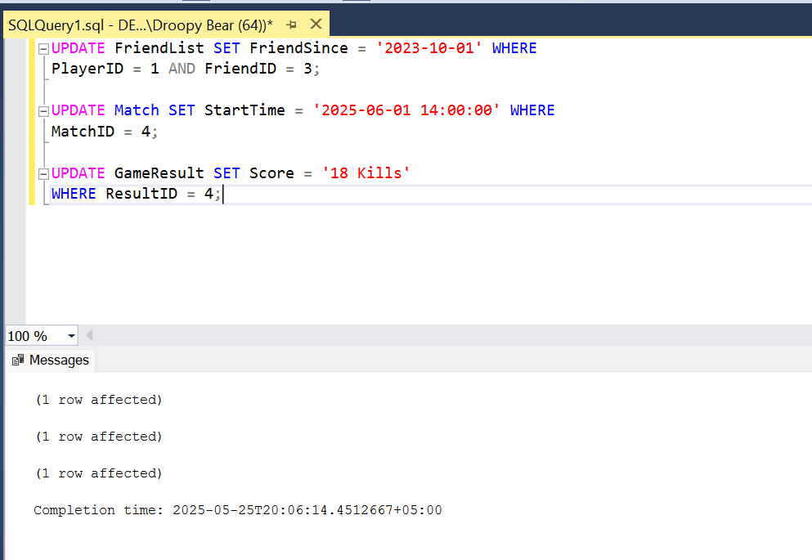

**DELETION QUERIES**

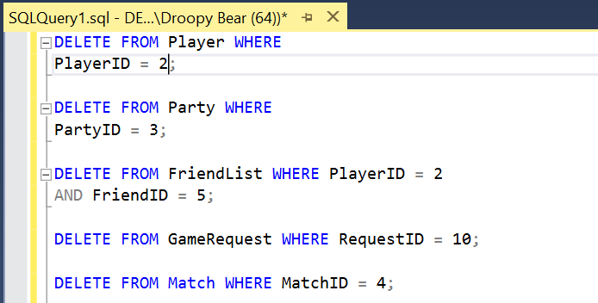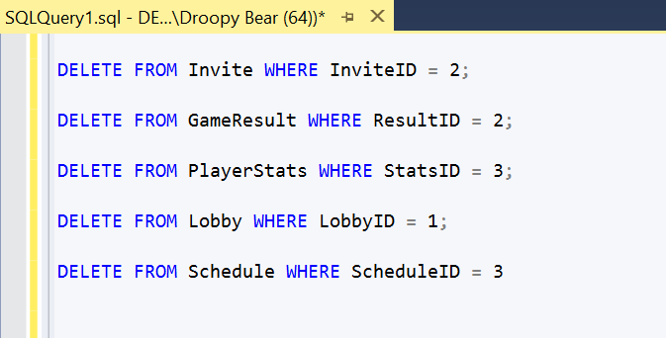

**PROCEDURES**

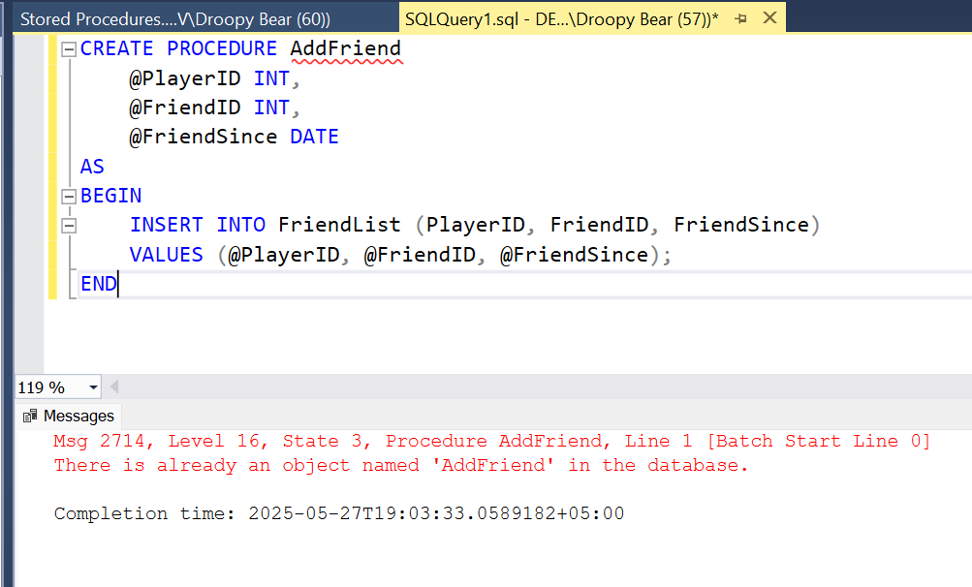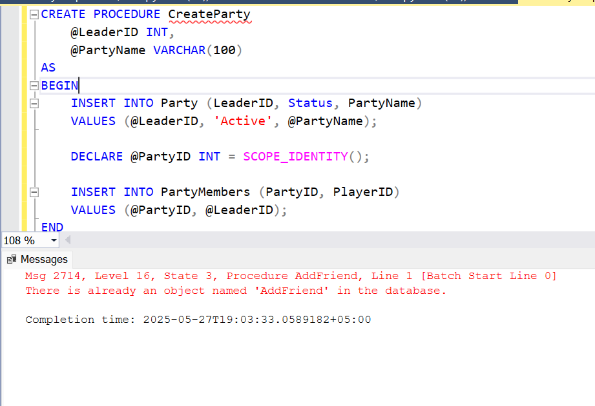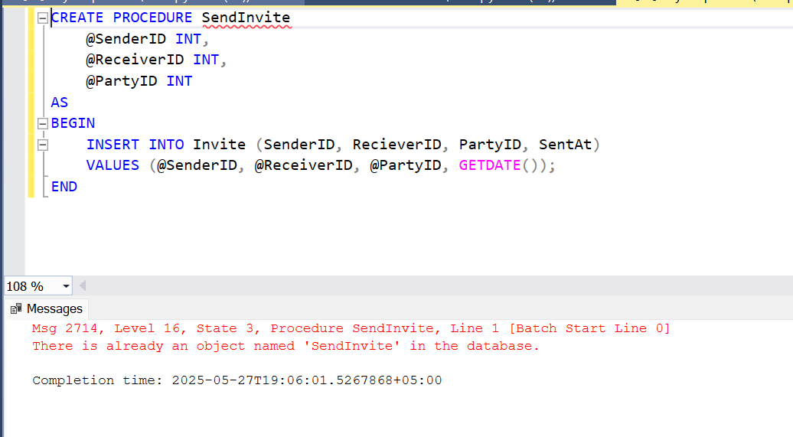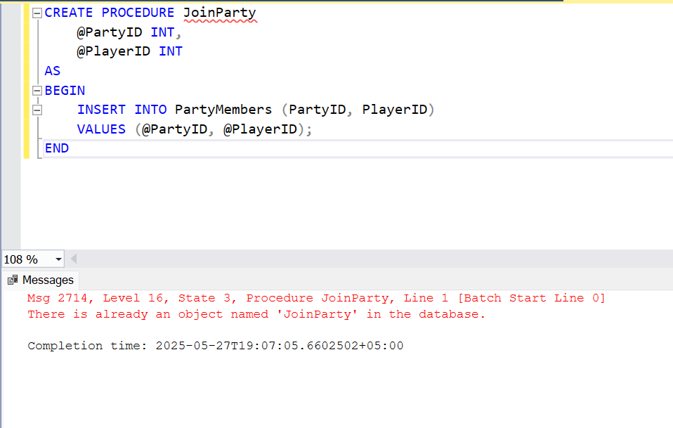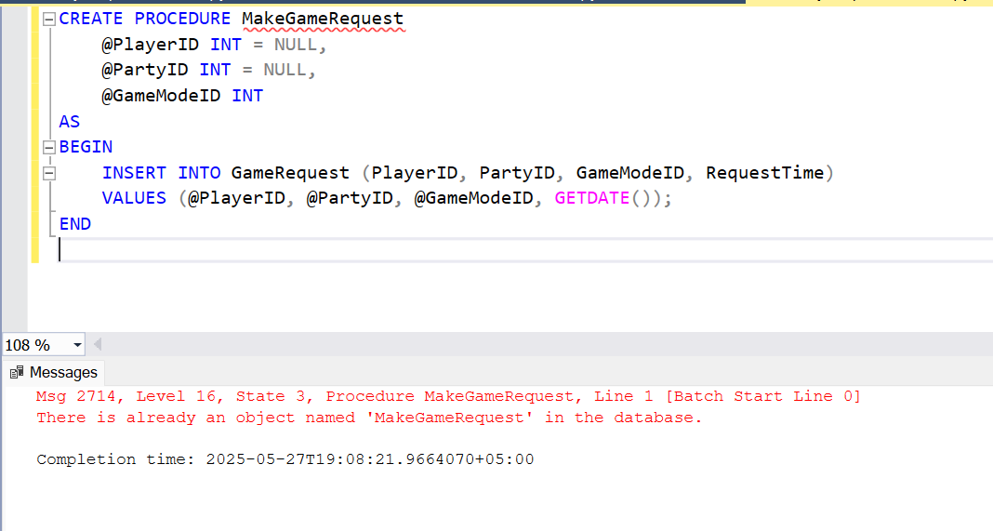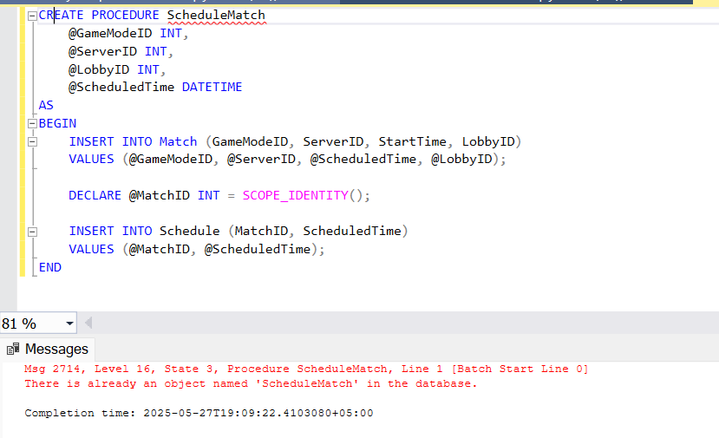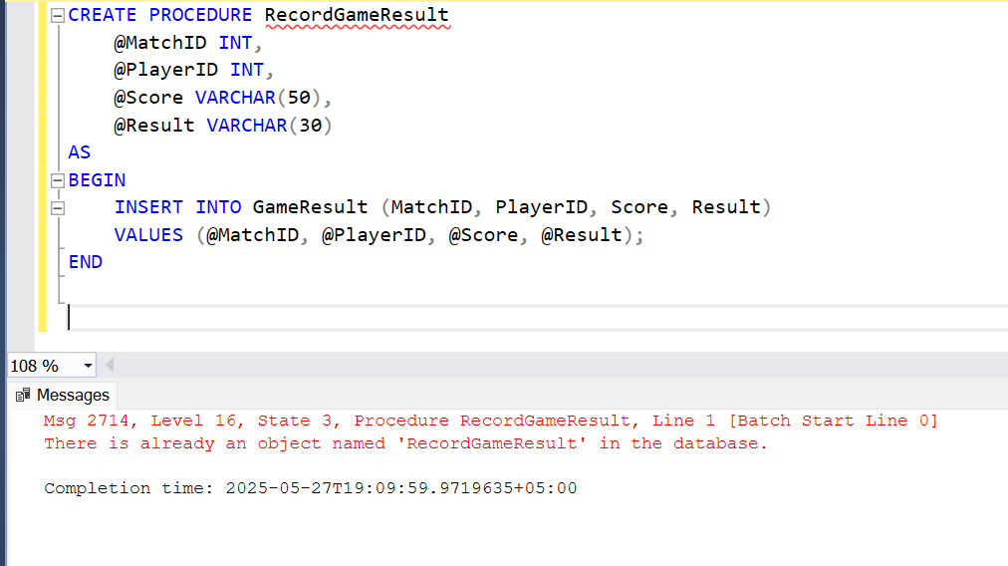

**DUMMY FRONT END**

**(NOT CONNECTED WITH BACKEND)**

